Credit Card State Bank Of India

**1234 5678 9012 3456**

**0123 0/80**

**SUNIDHI CHAUDHARY**

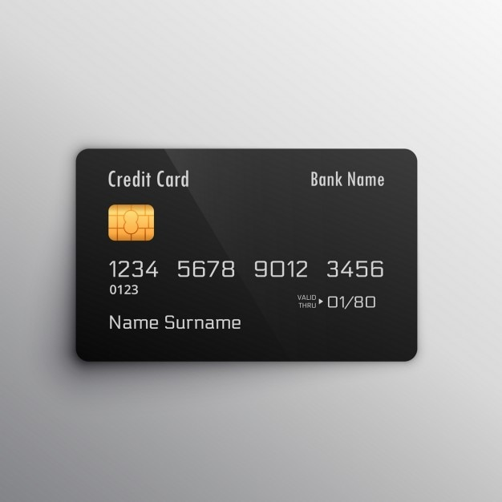 C